**CROP RECOMMENDATION USING MACHINE LEARNING ALGORITHMS**

Project Report

**Abstract:**

In the last couple of years Crop analysis and prediction has emerged as a field on the go that becomes a center point of the process of agricultural optimization. Crop recommendation is integral part of farming that allows farmers to explore more productive options for their land and harvest condition. In the past, the information about a certain disease was passed between the keyboard experts and the end-users that often required big efforts and significant time loss. Furthermore, in view of the expected UN-projections of 9.7 billion human beings by 2050, it's evident that food has to be produced more sustainably. Machine learning approaches could be a critical component in help farmers take quick decisions on optimal use of land, fighting pests and diseases to increase yield while at the same time rebuilding crops fertility and restore nutrients missing in the soil. In this paper, crop recommendation through the use of different machine-learning capabilities would be done. Our system utilizes multiple aspects, such as soil structure and climate index, job to correctly know the most favorable crops for certain areas. The technology has a serious prospect of revolutionizing field recommendation of crops, thus improving the yields of all farmers irrespective of size thereby increasing sustainability, and profitability across the sector.

**Introduction:**

Urban farming occurs when someone living in a city or heavily populated town repurposes their green space to grow food and/or raise smaller animals (think goats, rabbits, chickens, turkeys). Not every urban farm has to be at the owner's house; some urban farmers lease land and work the soil in other backyards, utilize rooftops or even farm indoors. Unlike a personal garden, an urban farmer grows to feed the community, sometimes selling it for little or no profit.

Types of Urban Farms:

To get started, look at the available space and how much food you want to grow. The types of plants will also play into it. For example, you can't grow runners like squash or cucumbers if you don't have room for them.

Rooftop Gardening: New York City and other urban centers boast rooftop gardens, but many of these green patches are urban farms. They're typically made of raised beds and usually get full sun, which is great but sometimes challenging; it's best for tomatoes, squash, peppers, potatoes, eggplant, and basil. (Shade structures can be created to protect and grow more delicate plants such as lettuces, radishes, herbs, and peas.) Rooftop farms are also great for keeping honeybees, which help with pollination and provide honey. The hardest part of maintaining a rooftop farm is getting water up there. Some buildings have water access on the roof, but many farmers run hoses up the side of the building or haul water each day. An irrigation system can help, if available. As a bonus, rooftop gardens improve air quality and reduce urban heat islands, which is when urban areas heat up more than rural areas1.

Vertical Farming: In this innovative method, farming happens indoors via stacked layers in a controlled environment, using hydroponics, aquaponics, and aeroponics. This type of farming without soil is great for crisp and clean lettuces, greens, microgreens, mushrooms, tomatoes, and strawberries. Vertical farming loses less produce to pests and saves water, but it can be expensive to maintain a consistent growing environment and harder for plants to pollinate if they aren't outside.

Yard Farming: Some urban farms are the size of a housing lot in someone's backyard, while others use the front yard and backyard to grow food. Imagine a mix of raised beds and ground gardens, green walls, small greenhouses, hoop houses, and areas for animals. The whole yard is typically utilized, with planting based on season. Many yard farms use compost areas and rain barrels for collecting water (though check the local laws surrounding water rights).

Animals: Raising animals and bees can be done on its own or alongside plants depending on the local laws. Urban farms favor smaller animals such as chickens, goats, turkeys, rabbits, and ducks. All animals need enough room to move, grow and live, as well as plenty of food and water and predator-proof shelter. Check the local cottage laws in regard to processing meat on a small farm, though not every city allows for it to be sold. Eggs fall into a different category so check the rule, though keep in mind any meat or dairy can be given away for free.

India is the leading producer of agricultural goods. The agriculture industry employs 58 percent of the total Indian population as well as contributes 17% to the country’s GDP. Crops rely on a multitude of factors, including the type of soil, amount of rainfall and sunlight, irrigation, fertilizer use, insect presence, and land preparation. One of the most frequent challenges that Indian farmers must overcome is choosing crops in accordance with the terrain and the climate. Considering the fact that climatic conditions and characteristics of soil have a direct impact on crop yield, it is necessary to develop crop management practices that consider the appropriateness of the site and the soil. Weather and agriculture are closely intertwined; therefore, it is essential to adapt to changing climatic trends in a productive way. Using climate-smart agricultural practices may help increase productivity and produce quality crops.

Precision agriculture has recently brought about significant advances in the world of agriculture, with an emphasis on irrigation systems, fertilization, crop monitoring and yield prediction. Choosing the appropriate crop in relation to location-specific soil factors and climatic conditions is also vital for enhancing production. Therefore, farmers must be equipped with instruments that allow them to choose the best crop suited for the region’s unique meteorological and soil conditions. In developing nations, using machine learning for agricultural planning objectives has resulted in the development of applications such as crop recommendation, crop disease diagnosis, fertilizer management and so on [9]. The farmers would profit from the development of crop recommendation systems that consider location-specific factors. The research described in this article tries to create a recommendation algorithm that offers highest produce based on terrain and climate factors unique to a particular region.

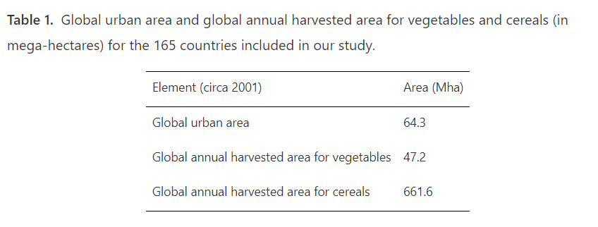

**Analysis and Research:**

In agriculture, a lot of work is carried out to predict crop yield, select suitable crops based on weather conditions and soil data, etc. In20, the authors proposed a stochastic model for forecasting seasonal weather conditions. The proposed model conflates with another agriculture model developed for crop simulations to forecast crop production and monetary return. This model was also fruitful in analyzing the risks associated with the various climatic conditions. The model was tested with the dataset of the crop Maize for two different geographical areas of the state of Argentina. In21, the authors proposed another aggregate model to manage various agricultural activities and predict the crop yield in Europe. The proposed model has been experimented with for the crop of wheat. The authors claimed that their model is more accurate and reliable than existing systems. This model was based on the probability distribution function. In22, the authors presented a yield prediction system for the state of Visakhapatnam. This model works in two layers. In the first phase, it uses a modular artificial neural network (MANN) to predict the rainfall in the region. In the second phase, the result of the first phase, along with some other parameters, has been used to predict crop yield. The authors implemented the model for the crops of bajra, ragi, rice, and maze. The authors present a nutrient-based soil classification system. This system divides the soil into three classes using KNN. This model used different soil parameters: nitrogen level, pH value, potassium, organic carbon, phosphorus, and micronutrients. In23, the authors presented a model to select the suitable crop to obtain the maximum yield. This model also recommends the order in which crops should be grown during the year on a piece of land to give maximum yield. The authors categorized the crops as seasonal, whole-year, short-term, and long-term. The parameters considered are water level to decide the suitability of the crop to be sown, soil type, type of crop, and weather conditions. This model advises crop sequence to obtain maximum produce based on crop type and sowing time. A smart crop selection model is presented in24. Authors used IoT to gather soil parameters and weather conditions in their system. Various soil parameters used to train the model are salinity, moisture, humidity, and temperature. Then 3D clustering was applied to compare the various farming techniques used for a particular crop. Several prediction algorithms such as random forest, naïve Bayes', and decision trees are presented by different authors to choose appropriate crops using weather conditions and soil parameters. In25, the authors presented another aggregate method to choose suitable crops considering weather and soil conditions. This model uses k-nearest neighbor, naïve Bayes', random forest, and CHAID algorithms. Classification criteria used in this model are soil color, root depth, texture, and drainage capacity of the land. In26, the authors presented a naïve Bayes' classification model to predict suitable crops considering various environmental parameters like temperature, rainfall, moisture, and pressure. Experiments were performed for rice, cotton, chilly, and maize crops. This model also suggests an appropriate time to sow and harvest a crop. In27, the authors highlighted the importance of agriculture and the dependency of the people on it in India. The authors discussed important soil parameters, like pH value, nutrition level, and drainage capacity which play an important role in crop selection and yield. Three different ML techniques, i.e., KNN, Decision Tree, and Naïve Bayes algorithm are applied by the authors for crop yield prediction. In28, authors used GBDT and ridge regression, KNN, and SVM to predict crop yield in Europe. Authors used soil parameters in their work to make yield predictions in the various regions of the country taking 35 different cases.

Different technologies and automations such as simple integrated circuits to more complex microcontrollers, sensors, micro-computers and Internet of Things (IoT) applications have been implemented in agriculture through smart farming applications (SFT) that promote data acquisition, data analysis-evaluation and precision application, with significant positive impacts in environmental, economic and labor parameters. However, these applications are present in large-scale farming, while very limited work has been done in small-scale, automated UA.

Data acquisition tasks are supported by the growing computer vision techniques and access to multiple sensory data while data analysis and evaluation tasks are becoming more and more common in agricultural research. A combination of data acquisition with data analysis and evaluation is also done in the continuously developing domain of object detection based on convolutional neural networks (CNNs). Many different algorithms have been developed and further optimized with successful application examples dealing with leaf disease detection plant disease detection land cover classification crop type classification, plant recognition, crop yield estimation, fruit counting, weed management and many more.

**Exploratory Data Analysis (EDA):**

Dataset Preview:

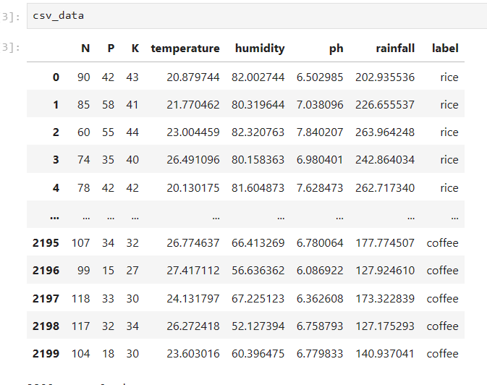

N (Nitrogen):

Nitrogen (N) is one of the essential macronutrients required for plant growth and development. It plays a crucial role in various physiological processes, including photosynthesis, protein synthesis, and overall plant metabolism. The N column in the dataset likely represents the nitrogen content in the soil, measured in some appropriate unit (e.g., kilograms per hectare or percentage of soil composition).

P (Phosphorus):

Phosphorus (P) is another essential macronutrient necessary for plant growth, particularly in the development of roots, flowers, and fruits. It is involved in energy transfer processes, nucleic acid synthesis, and overall plant metabolism. The P column in the dataset likely represents the phosphorus content in the soil, measured in a suitable unit.

K (Potassium):

Potassium (K) is a macronutrient critical for various physiological processes in plants, including enzyme activation, osmoregulation, and stomatal regulation. It contributes to overall plant vigor, disease resistance, and stress tolerance. The K column in the dataset likely represents the potassium content in the soil, measured in an appropriate unit.

Temperature:

Temperature is a vital environmental factor that influences plant growth and development. Different crops have specific temperature requirements for optimal growth, flowering, and fruit set. The temperature column in the dataset likely represents the average temperature recorded in the area where the crops are grown, measured in degrees Celsius or Fahrenheit.

Humidity:

Humidity refers to the amount of moisture present in the air and soil, which directly affects plant transpiration, nutrient uptake, and overall water balance. Different crops have varying humidity requirements depending on their water needs and susceptibility to fungal diseases. The humidity column in the dataset likely represents the relative humidity level recorded in the area where the crops are cultivated.

pH (Soil pH):

Soil pH is a measure of the acidity or alkalinity of the soil, which significantly influences nutrient availability, microbial activity, and plant nutrient uptake. Different crops have specific pH preferences for optimal growth and nutrient absorption. The pH column in the dataset likely represents the soil pH level measured in the agricultural fields where the crops are planted.

Rainfall:

Rainfall is a crucial climatic factor that directly impacts crop water supply, soil moisture content, and overall agricultural productivity. Different crops have varying water requirements and tolerance to drought or excess moisture. The rainfall column in the dataset likely represents the amount of precipitation received in the area where the crops are cultivated, measured in millimeters or inches.

Label (Crop Type):

The label column in the dataset represents the target variable or the crop types recommended for cultivation based on the given environmental and soil parameters. Each entry in the label column corresponds to a specific crop type (e.g., wheat, rice, maize, soybean) recommended by the crop recommendation system based on the input features (N, P, K, temperature, humidity, pH, rainfall).

Histograms for each parameter:

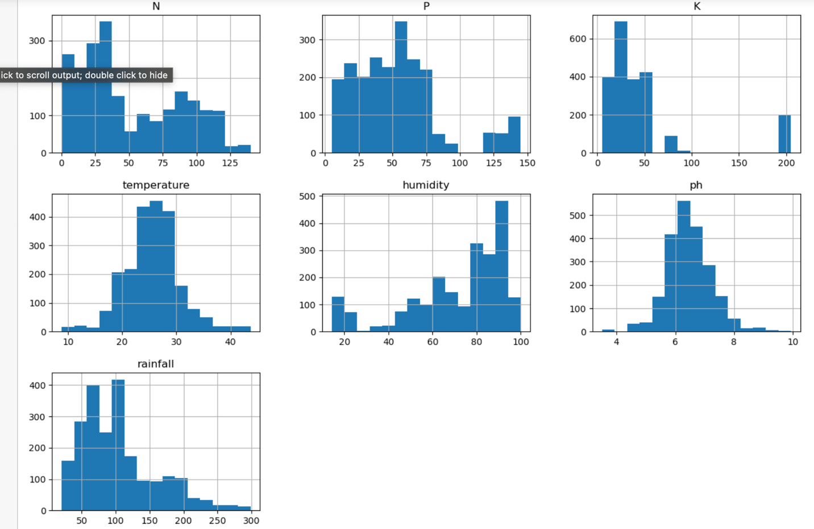

Each histogram provides a visual summary of the respective parameter's variation within the dataset, and this helps in identifying patterns, outliers, and potential relationships with crop performance. For example, the rainfall histogram illustrates the distribution of rainfall values. Peaks in the histogram indicates periods of heavy rainfall or distinct seasonal patterns.

Temperature Vs Rainfall:

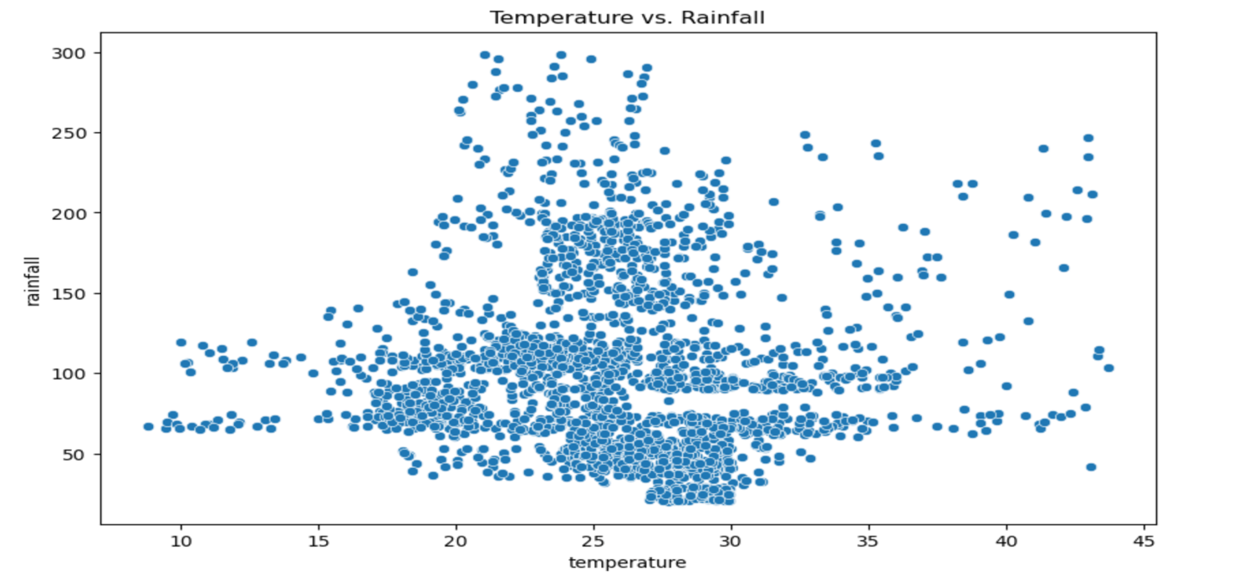

The temperature versus rainfall plot provides valuable insights on the climatic conditions affecting agriculture, including seasonal variations, correlations between variables, identification of climate zones, and potential impacts on crop growth and environmental risks. Here, we have a heavy rainfall for particular range of temperatures which is from 20 to 30. As the temperature increases, we can notice that the rainfall is gradually decreases.

Humidity Vs Ph:

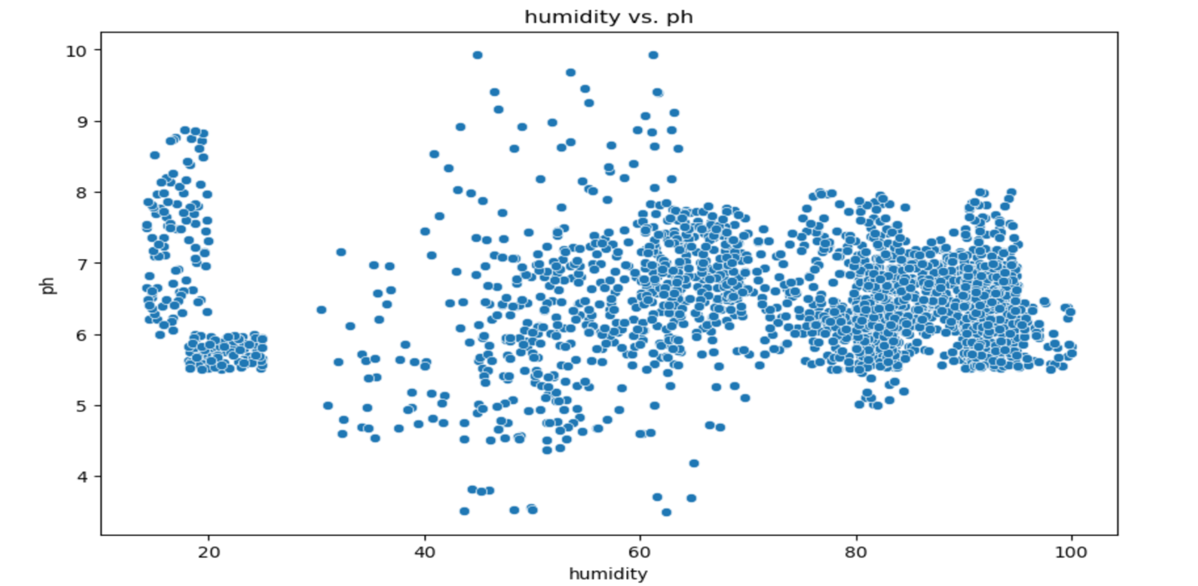

The humidity versus pH plot offers valuable insights into soil health, crop suitability, environmental influences, water management, and pest dynamics, aiding in informed decision-making for efficient and sustainable agriculture.

Correlation matrix for numeric features:

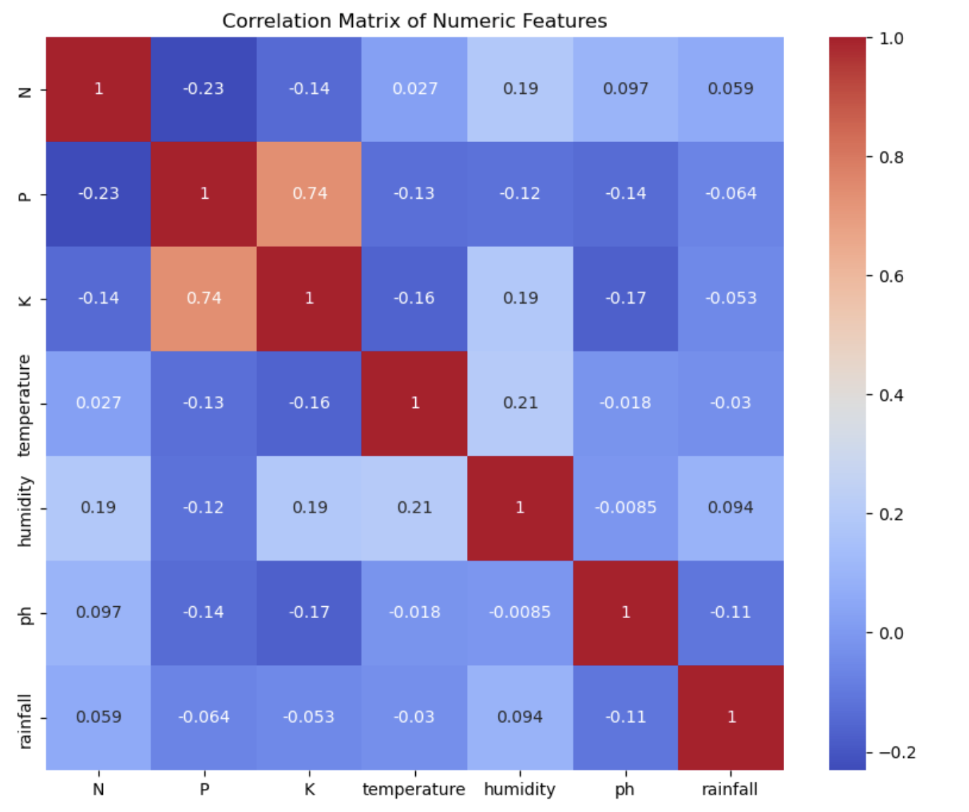

**Pairplot to visualize the relationship between different features and clusters:**

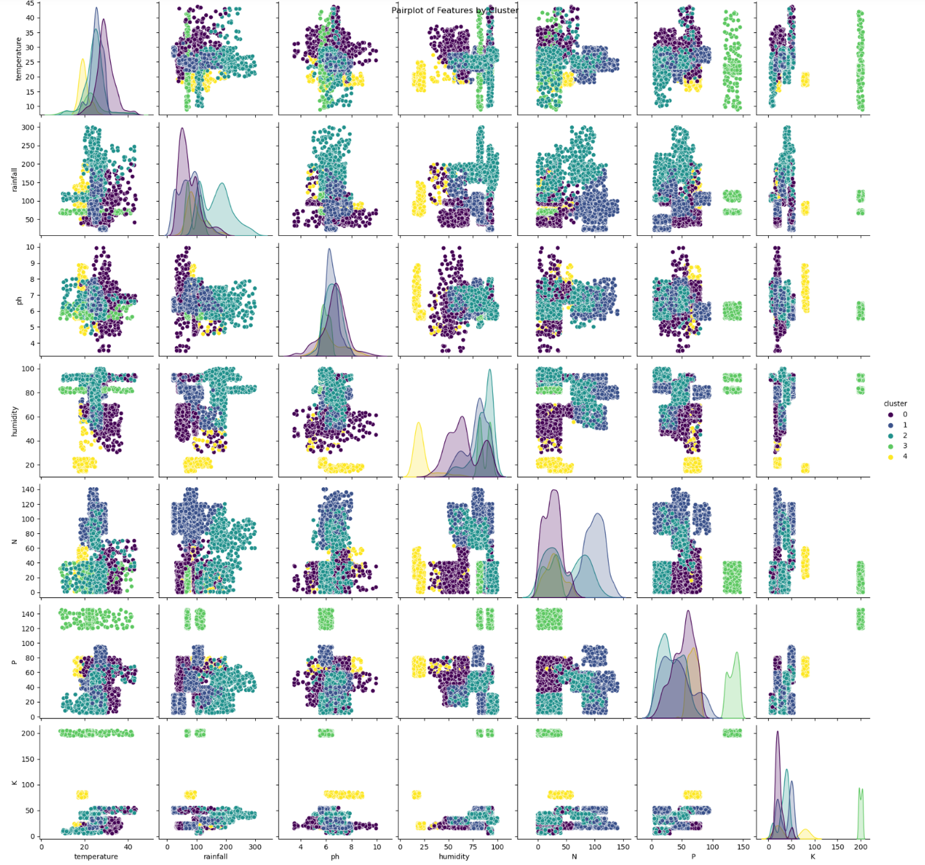

A pair plot is used to visualize the distribution of these parameters across different clusters and crop types. This pair plot will create a grid of plots each showing the relationship between two of the features, colored by the cluster they belong to. This is a good way to visualize multidimensional data and can help to see how well the clusters are formed with respect to the different agricultural parameters given in the dataset.

Count plot to visualize the distribution of crops within each cluster:

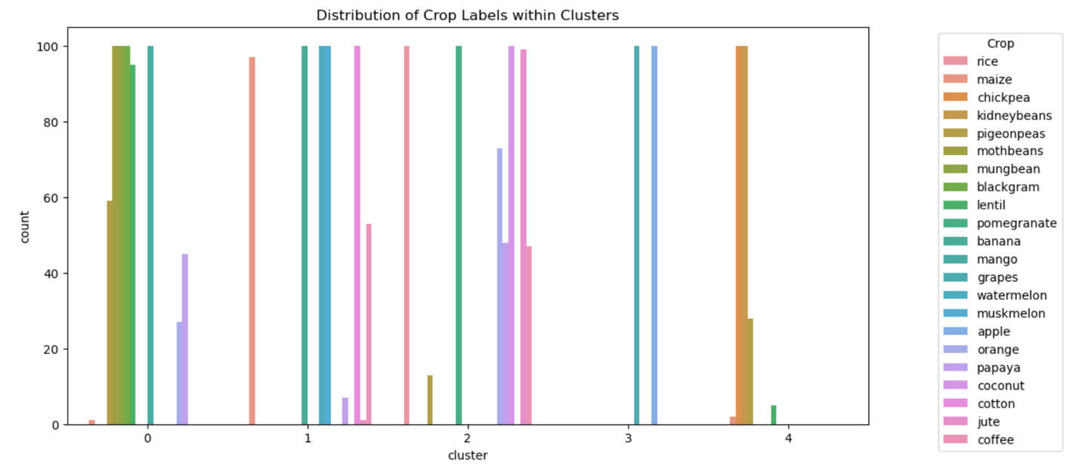

A count plot visualizes how different crops (labels) are distributed within each cluster, which can give insights into whether certain types of crops have similar environmental and soil requirements.

**Crop Recommendation Models:**

So basically, What is ML in Agriculture:

Machine learning (ML) in agriculture has emerged as a transformative technology, offering innovative solutions to various challenges faced by the agricultural sector. Here are some key areas where machine learning is being applied in agriculture:

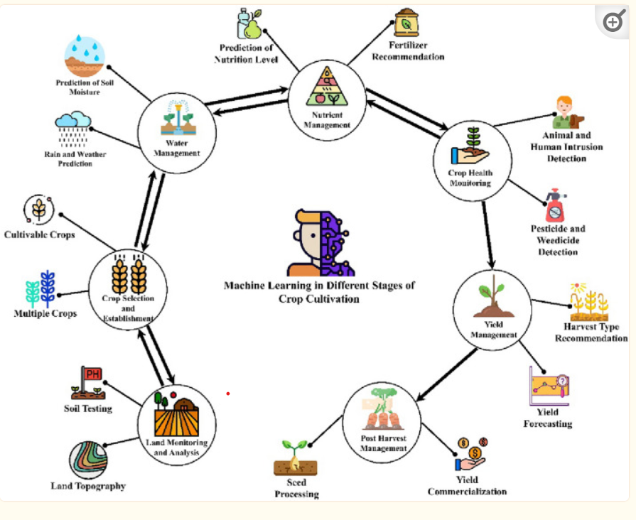

In this project (Crop Recommendation) we will be using few algorithms for prediction and one for outlier detection. A brief introduction to the algorithms is as follows:

**Multiple Linear Regression:**

Multiple Linear Regression (MLR) is a fundamental statistical technique used for modeling the relationship between a dependent variable and multiple independent variables. In the context of crop recommendation, MLR can be employed to predict crop yields based on various factors such as soil characteristics, climate conditions, and agricultural practices. How it Works:

MLR assumes a linear relationship between the independent variables and the dependent variable. The algorithm calculates the coefficients for each independent variable to minimize the difference between the predicted and actual values of the dependent variable. These coefficients represent the impact of each independent variable on the dependent variable, allowing for interpretation of their relative importance. Application in Crop Recommendation:

In crop recommendation systems, MLR can be utilized to predict the suitability of different crops for specific regions based on factors such as temperature, precipitation, soil pH, nutrient levels, and historical yield data. By analyzing these variables, MLR can provide insights into which crops are likely to thrive in a given area, helping farmers make informed decisions about crop selection.

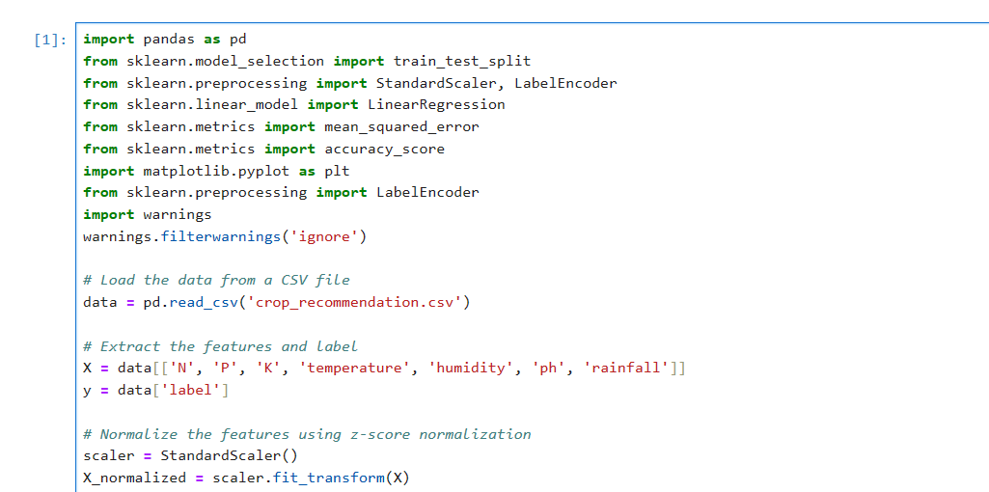

Here we are importing all the required modules for the algorithm  
and loading the data set.

In the next lines we are scaling the data which is read, in order to fit the model and get accurate results. Scaling involves fitting the available data between 0 and 1 so that the model could evaluate properly.

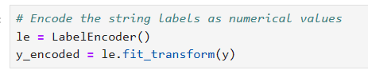

This is converting categorical column in data to the numerical in order to fit to the algorithm.

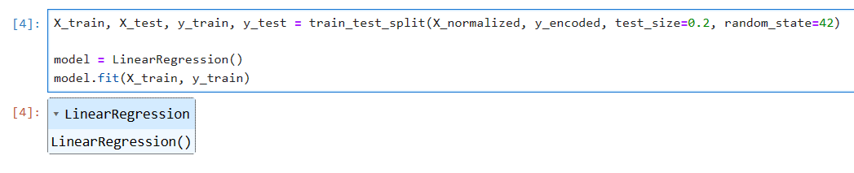

We are splitting the data into training and testing so that the model could understand the features 80% of the data is used for training and the remaining 20 % is use for testing the algorithm on the same data from where we can know the accuracy of the algorithm and how well it can be used further.

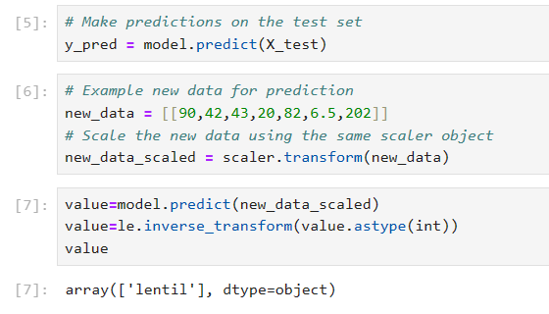

So here, basically we are using the same trained model to predict new values and you can see the output as above.

**Decision Tree:**

Decision Tree is a popular supervised learning algorithm used for classification and regression tasks. It is a tree-like structure where each internal node represents a feature, each branch represents a decision based on that feature, and each leaf node represents the outcome or predicted value. Decision trees are intuitive and easy to interpret, making them suitable for various applications, including crop recommendation. How it Works:

Decision trees partition the feature space into subsets based on the values of different features. The algorithm recursively splits the data into subsets, aiming to maximize the homogeneity of the target variable within each subset. The splitting process continues until a stopping criterion is met, such as reaching a maximum tree depth or achieving a minimum number of data points in each leaf node. Application in Crop Recommendation:

Decision trees can be employed in crop recommendation systems to generate rules for selecting appropriate crops based on environmental factors and crop requirements. By analyzing historical data on crop performance and environmental conditions, decision trees can identify the key features that influence crop suitability and recommend the most suitable crops for a given location.

Implementation:

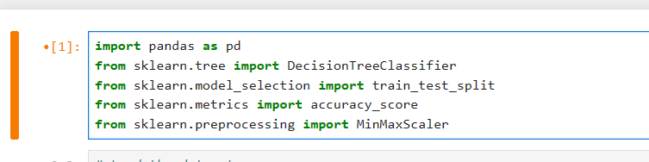  
Importing of modules same as Regression

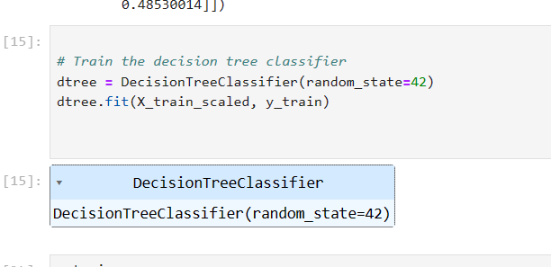

We are training the algorithm same as regression, note that the variables used here are already scaled and given as input to the algorithm.

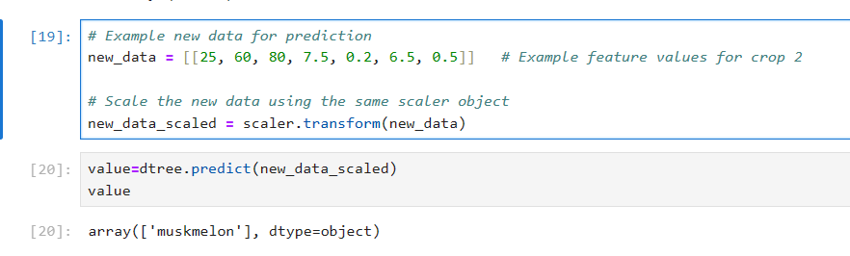

So, from above we can see the recommendation according to the values which we provide.

**Random Forest:**

Random Forest is an ensemble learning algorithm that builds multiple decision trees and combines their predictions to improve accuracy and robustness. It operates by constructing a multitude of decision trees during training and outputting the mode of the classes (classification) or the mean prediction (regression) of the individual trees. How it Works:

Random Forest creates a diverse set of decision trees by using random subsets of the training data and random subsets of the features for each tree. During prediction, each tree in the forest independently produces a prediction, and the final prediction is determined by aggregating the individual predictions, typically through a simple voting mechanism for classification tasks or averaging for regression tasks. Application in Crop Recommendation:

Random Forest is well-suited for crop recommendation tasks due to its ability to handle large datasets with high-dimensional feature spaces. By leveraging the power of ensemble learning, Random Forest can effectively capture complex relationships between environmental variables and crop suitability, leading to more accurate and robust recommendations compared to individual decision trees.

Implementation:

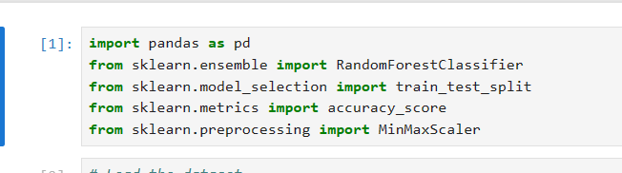  
Importing the necessary modules

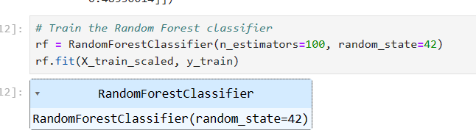

Training the algorithm after proper preparation of data and scaling.

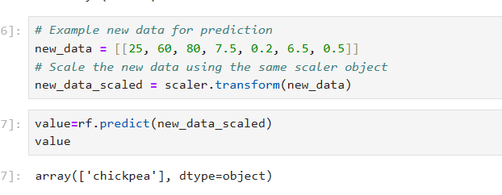

Prediction of a crop based on values.

**K-means Clustering:**

K-means Clustering is an unsupervised learning algorithm used for partitioning a dataset into a predetermined number of clusters. It aims to group similar data points together while keeping dissimilar data points in different clusters. K-means is widely used for clustering analysis in various domains, including agriculture. How it Works:

K-means begins by randomly selecting K centroids, which represent the initial cluster centers. It then iteratively assigns each data point to the nearest centroid and updates the centroids based on the mean of the data points assigned to each cluster. This process continues until convergence, where the centroids no longer change significantly, or a specified number of iterations is reached. Application in Crop Recommendation:

In crop recommendation, K-means clustering can be used to identify distinct groups of regions with similar environmental conditions or crop performance. By clustering regions based on factors such as climate, soil characteristics, and historical crop yields, K-means can help identify areas with comparable agro-climatic conditions and recommend suitable crops for each cluster. This approach facilitates tailored recommendations based on the specific characteristics of each region, improving the precision and relevance of crop recommendations.

Implementation:

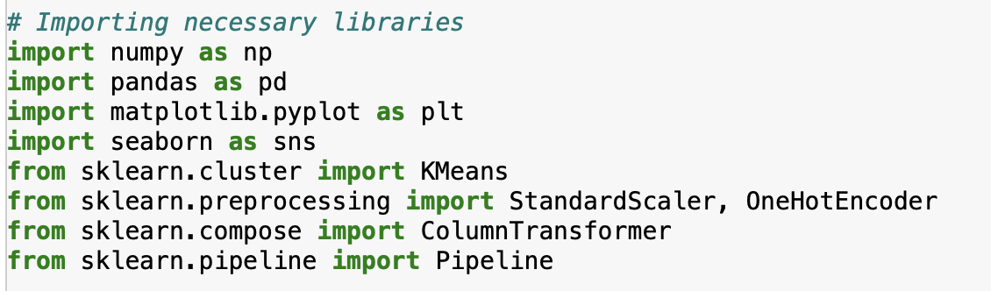

First, we import all the necessary libraries which are required for our project which is implemented using k means algorithm.

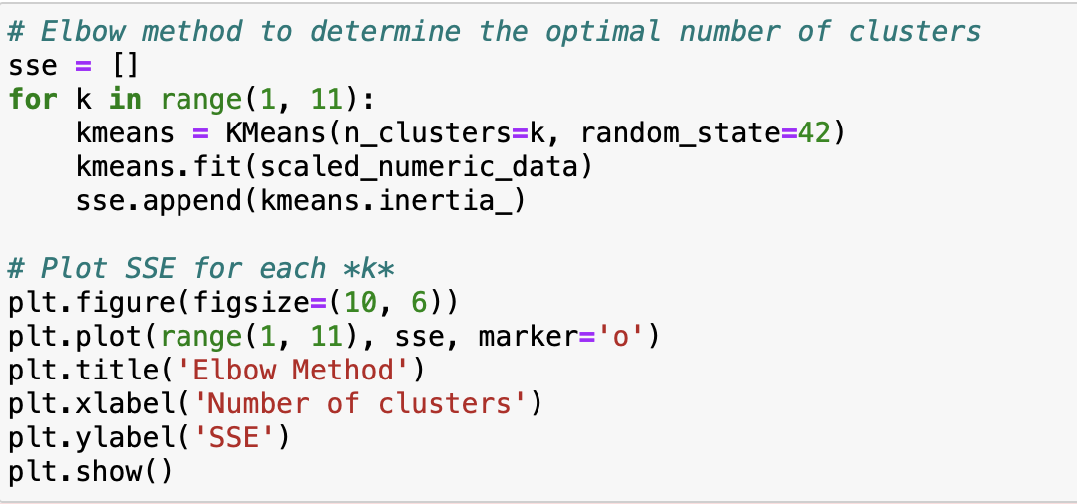

As we have to determine the number of clusters, we used the elbow method by plotting a graph.

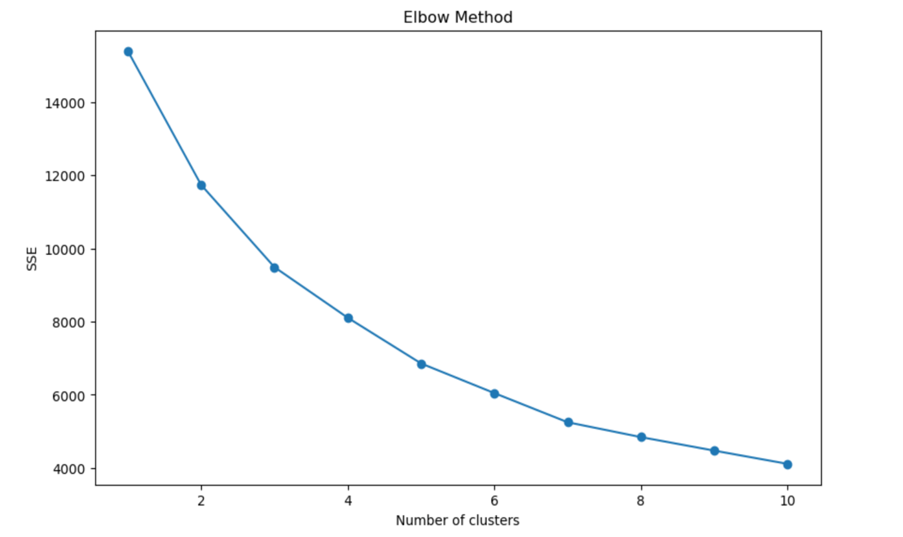

We have considered 5 as the elbow point from the above graph. So, the number of clusters in this case would be 5.

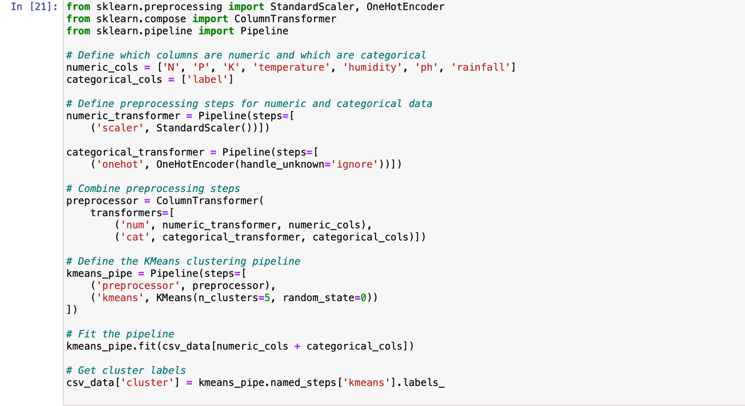

Here, we utilized a machine learning pipeline that incorporates preprocessing and clustering steps to analyze data, specifically for clustering purposes. Here, there are two sub-pipelines. One sub-pipeline scales numeric columns using StandardScaler and the other encodes categorical columns using OneHotEncoder. Then the ColumnTransformer combines the numeric and categorical transformers. The KMeans pipeline first applies the preprocessing defined by preprocessor, then performs clustering with KMeans. Then, this pipeline is fitted to the data.

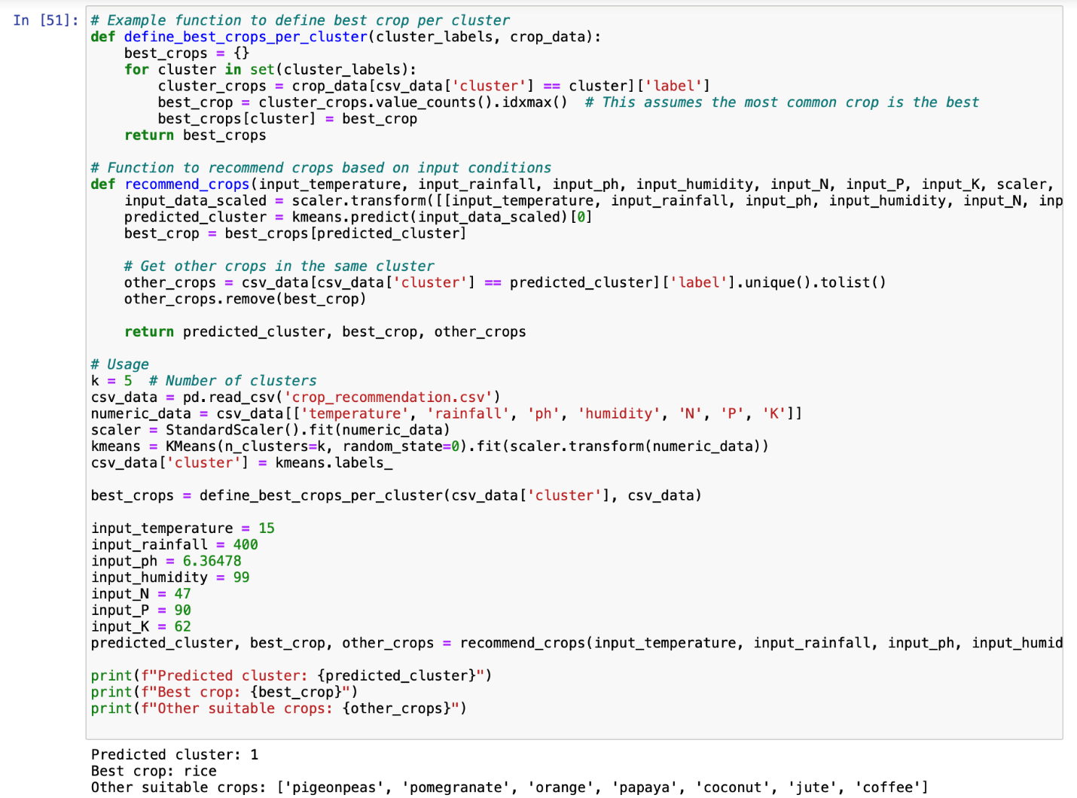

Finally, the best crop, other suitable crops and the predicted cluster will be returned as the output.

**Accuracy Scores:**

Scores: **Linear Regression**

R-squared: 0.25634813007312407

Adjusted R-squared: 0.24429821551412378

Mean Squared Error (MSE): 31.474262588659084

Root Mean Squared Error (RMSE): 5.6101927407762995

Mean Absolute Error (MAE): 4.433454392161998

Scores: **Decision trees**

Accuracy: 0.9863636363636363

Precision: 0.9868055555555556

Recall: 0.9863636363636363

F1 Score: 0.9863152866630287

Confusion Matrix:

[[23 0 0 0 0 0 0 0 0 0 0 0 0 0 0 0 0 0 0 0 0 0]

[ 0 21 0 0 0 0 0 0 0 0 0 0 0 0 0 0 0 0 0 0 0 0]

[ 0 0 20 0 0 0 0 0 0 0 0 0 0 0 0 0 0 0 0 0 0 0]

[ 0 0 0 26 0 0 0 0 0 0 0 0 0 0 0 0 0 0 0 0 0 0]

[ 0 0 0 0 27 0 0 0 0 0 0 0 0 0 0 0 0 0 0 0 0 0]

[ 0 0 0 0 0 17 0 0 0 0 0 0 0 0 0 0 0 0 0 0 0 0]

[ 0 0 0 0 0 0 17 0 0 0 0 0 0 0 0 0 0 0 0 0 0 0]

[ 0 0 0 0 0 0 0 14 0 0 0 0 0 0 0 0 0 0 0 0 0 0]

[ 0 0 0 0 0 0 0 0 22 0 0 0 0 0 0 0 0 0 0 0 1 0]

[ 0 0 0 0 0 0 0 0 0 20 0 0 0 0 0 0 0 0 0 0 0 0]

[ 0 0 0 0 0 0 0 0 0 0 11 0 0 0 0 0 0 0 0 0 0 0]

[ 0 0 0 0 1 0 0 0 0 0 0 20 0 0 0 0 0 0 0 0 0 0]

[ 0 0 0 0 0 0 0 0 0 0 0 0 19 0 0 0 0 0 0 0 0 0]

[ 0 0 1 0 0 0 0 0 0 0 1 0 0 22 0 0 0 0 0 0 0 0]

[ 0 0 0 0 0 0 0 0 0 0 0 0 0 0 19 0 0 0 0 0 0 0]

[ 0 0 0 0 0 0 0 0 0 0 0 0 0 0 0 17 0 0 0 0 0 0]

[ 0 0 0 0 0 0 0 0 0 0 0 0 0 0 0 0 14 0 0 0 0 0]

[ 0 0 0 0 0 0 0 0 0 0 0 0 0 0 0 0 0 23 0 0 0 0]

[ 0 0 0 0 0 0 0 0 0 0 0 0 0 0 0 0 0 0 23 0 0 0]

[ 0 0 0 0 0 0 0 0 0 0 0 0 0 0 0 0 0 0 0 23 0 0]

[ 0 0 0 0 0 0 0 0 2 0 0 0 0 0 0 0 0 0 0 0 17 0]

[ 0 0 0 0 0 0 0 0 0 0 0 0 0 0 0 0 0 0 0 0 0 19]]

Scores: **Random Forest**

Accuracy: 0.9931818181818182

Precision: 0.9937348484848485

Recall: 0.9931818181818182

F1 Score: 0.9931754816901672

Confusion Matrix:

[[23 0 0 0 0 0 0 0 0 0 0 0 0 0 0 0 0 0 0 0 0 0]

[ 0 21 0 0 0 0 0 0 0 0 0 0 0 0 0 0 0 0 0 0 0 0]

[ 0 0 20 0 0 0 0 0 0 0 0 0 0 0 0 0 0 0 0 0 0 0]

[ 0 0 0 26 0 0 0 0 0 0 0 0 0 0 0 0 0 0 0 0 0 0]

[ 0 0 0 0 27 0 0 0 0 0 0 0 0 0 0 0 0 0 0 0 0 0]

[ 0 0 0 0 0 17 0 0 0 0 0 0 0 0 0 0 0 0 0 0 0 0]

[ 0 0 0 0 0 0 17 0 0 0 0 0 0 0 0 0 0 0 0 0 0 0]

[ 0 0 0 0 0 0 0 14 0 0 0 0 0 0 0 0 0 0 0 0 0 0]

[ 0 0 0 0 0 0 0 0 23 0 0 0 0 0 0 0 0 0 0 0 0 0]

[ 0 0 0 0 0 0 0 0 0 20 0 0 0 0 0 0 0 0 0 0 0 0]

[ 0 0 0 0 0 0 0 0 0 0 11 0 0 0 0 0 0 0 0 0 0 0]

[ 0 0 0 0 0 0 0 0 0 0 0 21 0 0 0 0 0 0 0 0 0 0]

[ 0 0 0 0 0 0 0 0 0 0 0 0 19 0 0 0 0 0 0 0 0 0]

[ 0 0 0 0 0 0 0 0 0 0 1 0 0 23 0 0 0 0 0 0 0 0]

[ 0 0 0 0 0 0 0 0 0 0 0 0 0 0 19 0 0 0 0 0 0 0]

[ 0 0 0 0 0 0 0 0 0 0 0 0 0 0 0 17 0 0 0 0 0 0]

[ 0 0 0 0 0 0 0 0 0 0 0 0 0 0 0 0 14 0 0 0 0 0]

[ 0 0 0 0 0 0 0 0 0 0 0 0 0 0 0 0 0 23 0 0 0 0]

[ 0 0 0 0 0 0 0 0 0 0 0 0 0 0 0 0 0 0 23 0 0 0]

[ 0 0 0 0 0 0 0 0 0 0 0 0 0 0 0 0 0 0 0 23 0 0]

[ 0 0 0 0 0 0 0 0 2 0 0 0 0 0 0 0 0 0 0 0 17 0]

[ 0 0 0 0 0 0 0 0 0 0 0 0 0 0 0 0 0 0 0 0 0 19]]

**Streamlit Application:**

Streamlit is an open-source Python library that allows you to create interactive web applications for machine learning, data science, and other purposes with minimal effort. It simplifies the process of building and sharing data-driven applications by providing an intuitive and user-friendly interface.

**Key Features of Streamlit:**

Easy-to-Use Interface: Streamlit provides a simple and intuitive Python API, allowing users to create interactive web applications using familiar Python scripting.

Rapid Development: With Streamlit, you can quickly prototype and deploy web applications without the need for HTML, CSS, or JavaScript coding. The library handles the web interface, so you can focus on your data analysis and visualization tasks.

Interactive Widgets: Streamlit offers a variety of interactive widgets, such as sliders, dropdowns, checkboxes, and text inputs, which enable users to interact with data and customize visualizations in real-time.

Automatic Updates: Streamlit automatically updates the web application in response to changes in the underlying Python code. This makes it easy to experiment with different parameters and instantly see the results.

Integration with Data Libraries: Streamlit seamlessly integrates with popular data libraries such as Pandas, Matplotlib, Plotly, and scikit-learn, allowing you to leverage their functionalities to create rich and interactive visualizations.

**VS-Code for Streamlit:**

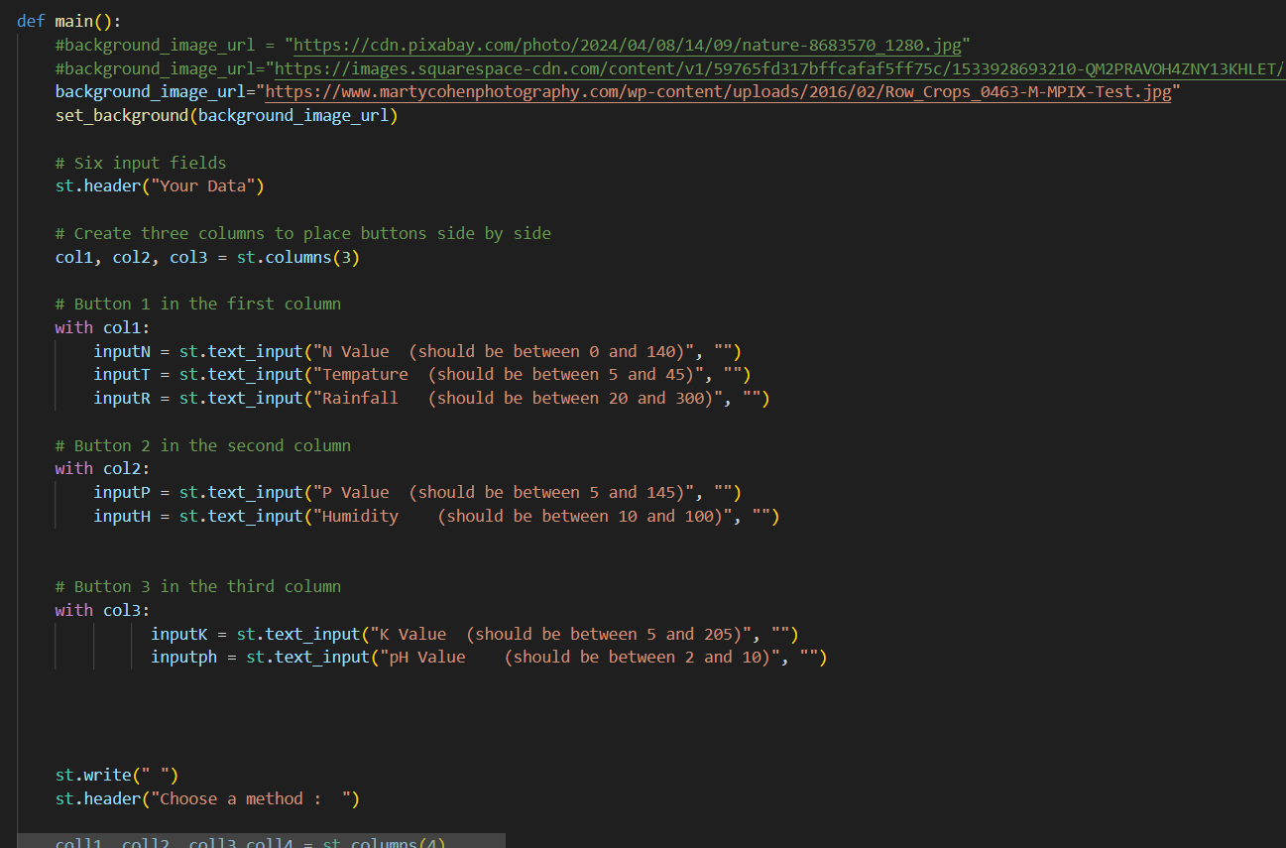

**Front End Application:**

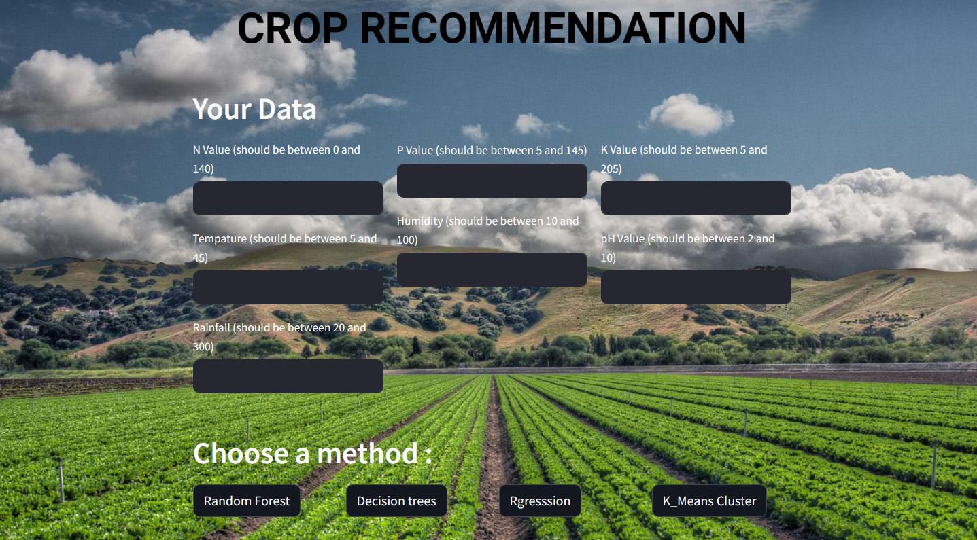

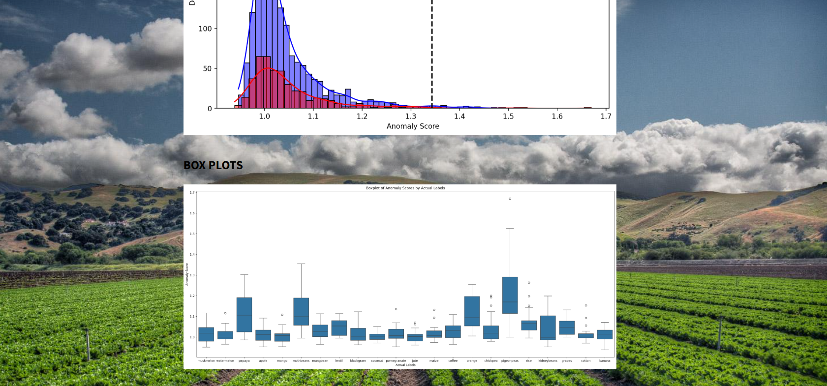

**Summary:**

In an overall, this project aims to develop a crop recommendation system using machine learning algorithms to assist farmers in selecting suitable crops for cultivation based on various environmental factors and agricultural parameters. By analyzing historical data on climate conditions, soil properties, crop yields, and other relevant variables, the system will generate personalized recommendations to maximize agricultural productivity and sustainability.

**References:**

20. Apipattanavis S, Bert F, Podestá G, Rajagopalan B. Linking weather generators and crop models for assessment of climate forecast outcomes. *Agric. For. Meteorol.*2010;**150**:166–174. doi: 10.1016/j.agrformet.2009.09.012. [[CrossRef](https://doi.org/10.1016%2Fj.agrformet.2009.09.012" \t "_blank)] [[Google Scholar](https://scholar.google.com/scholar_lookup?journal=Agric.+For.+Meteorol.&title=Linking+weather+generators+and+crop+models+for+assessment+of+climate+forecast+outcomes&author=S+Apipattanavis&author=F+Bert&author=G+Podest%C3%A1&author=B+Rajagopalan&volume=150&publication_year=2010&pages=166-174&doi=10.1016/j.agrformet.2009.09.012&)]

21. Cantelaube P, Terres J-M. Seasonal weather forecasts for crop yield modelling in Europe. *Tellus A Dyn. Meteorol Oceanogr.*2005;**57**:476–487. doi: 10.3402/tellusa.v57i3.14669. [[CrossRef](https://doi.org/10.3402%2Ftellusa.v57i3.14669" \t "_blank)] [[Google Scholar](https://scholar.google.com/scholar_lookup?journal=Tellus+A+Dyn.+Meteorol+Oceanogr.&title=Seasonal+weather+forecasts+for+crop+yield+modelling+in+Europe&author=P+Cantelaube&author=J-M+Terres&volume=57&publication_year=2005&pages=476-487&doi=10.3402/tellusa.v57i3.14669&)]

22. Khosla E, Dharavath R, Priya R. Crop yield prediction using aggregated rainfall-based modular artificial neural networks and support vector regression. *Environ. Dev. Sustain.*2020;**22**:5687–5708. doi: 10.1007/s10668-019-00445-x. [[CrossRef](https://doi.org/10.1007%2Fs10668-019-00445-x" \t "_blank)] [[Google Scholar](https://scholar.google.com/scholar_lookup?journal=Environ.+Dev.+Sustain.&title=Crop+yield+prediction+using+aggregated+rainfall-based+modular+artificial+neural+networks+and+support+vector+regression&author=E+Khosla&author=R+Dharavath&author=R+Priya&volume=22&publication_year=2020&pages=5687-5708&doi=10.1007/s10668-019-00445-x&)]

23. R. Kumar, M.P. Singh, P. Kumar, and J.P. Singh. Crop Selection Method to maximize crop yield rate using machine learning technique. IEEE 138–145.

24. Tseng F-H, Cho H-H, Wu H-T. Applying big data for intelligent agriculture-based crop selection analysis. *IEEE Access.*2019;**7**:116965–116974. doi: 10.1109/ACCESS.2019.2935564. [[CrossRef](https://doi.org/10.1109%2FACCESS.2019.2935564" \t "_blank)] [[Google Scholar](https://scholar.google.com/scholar_lookup?journal=IEEE+Access&title=Applying+big+data+for+intelligent+agriculture-based+crop+selection+analysis&author=F-H+Tseng&author=H-H+Cho&author=H-T+Wu&volume=7&publication_year=2019&pages=116965-116974&doi=10.1109/ACCESS.2019.2935564&)]

25. Pudumalar, S. *et al.* Crop recommendation system for precision agriculture 32–36. IEEE.

26. Priya, R., Ramesh, D. & Khosla, E. Crop prediction on the region belts of India: A Naïve Bayes MapReduce precision agricultural model 99–104. (IEEE).

27. Malik, P., Sengupta, S. & Jadon, J. S. Comparative analysis of soil properties to predict fertility and crop yield using machine learning algorithms 1004–1007. (IEEE).

28. Paudel D, et al. Machine learning for regional crop yield forecasting in Europe. *Field Crops Res.*2022;**276**:108377. doi: 10.1016/j.fcr.2021.108377. [[CrossRef](https://doi.org/10.1016%2Fj.fcr.2021.108377" \t "_blank)] [[Google Scholar](https://scholar.google.com/scholar_lookup?journal=Field+Crops+Res.&title=Machine+learning+for+regional+crop+yield+forecasting+in+Europe&author=D+Paudel&volume=276&publication_year=2022&pages=108377&doi=10.1016/j.fcr.2021.108377&)]

https://oppla.eu/casestudy/19448

https://www.ncbi.nlm.nih.gov/pmc/articles/PMC10520008/

https://www.mdpi.com/2673-4591/58/1/97

https://iopscience.iop.org/article/10.1088/1748-9326/9/6/064025/meta

https://zenodo.org/records/7059923

https://www.ncbi.nlm.nih.gov/pmc/articles/PMC8877115/#B17-micromachines-13-00250

https://ieeexplore.ieee.org/document/7891032

https://github.com/absmahi01/Krishi-ML-Based-Farming-Website/blob/main/Data%20raw/Fertilizer.csv

https://iopscience.iop.org/article/10.1088/1748-9326/9/6/064025/meta

https://www.thespruceeats.com/what-is-urban-farming-5188341